**IMAGE UPLOAD ASSIGNMENT**

1. **URL of Assignment** :- <http://ec2-34-209-125-251.us-west-2.compute.amazonaws.com:9090>
2. **Database Structure**:-

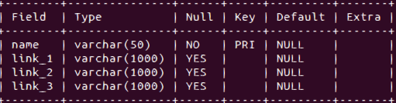

**Image 1**

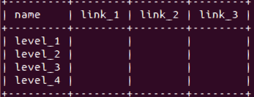

**Image 2**

The Image 1 is the database schema and Image 2 is actual view of my database.

I have named databases as img_table and attributes for it are name,link_1,link_2 & link_3.

3)**Website & API Code:**

Kindly Download the “ImageUploader_Website.zip” from the following link:

<https://github.com/sohitbhaskarwar/ImageUploader_Website>

1. **Technology Used : -**

UI:- Angular JS

Server-Side:- Node JS

Databases :- Mysql

NOTE:-

In first dropdown I have uploaded images in first 3 levels and level_4 is empty to test for you.

Second Dropdown is used to could upload images in respective level.

Last dropdown is use to see images in respective level.